Experiment No. 2

Data Manipulation and Analysis using Pandas

1. Aim
To study the Pandas library and understand how to perform data manipulation, and data
exploration, using Pandas data structures.

2. Objectives
• To understand the Pandas library and its importance in data science.
• To learn the basic data structures of Pandas: Series and DataFrame.
• To explore datasets using Pandas functions.
• To identify and analyze missing values in datasets.
• To perform data selection and indexing operations using Pandas.

3. Software Required
• Python 3.x
• Jupyter Notebook / Google Colab / Anaconda
• Pandas Library
• NumPy Library

4. Introduction to Pandas
Pandas is an open-source Python library used for data manipulation, analysis, and cleaning.
It provides powerful and flexible tools for working with structured and tabular data.
Pandas is widely used in data science, machine learning, and artificial intelligence because it allows efficient handling of large datasets.

Pandas integrates smoothly with other Python libraries such as:
• NumPy – Used for numerical computations.
• Matplotlib and Seaborn – Used for data visualization.
• Scikit-learn – Used for machine learning workflows.

Using Pandas, users can:
• Load datasets
• Clean and preprocess data
• Transform and manipulate data
• Analyze patterns and trends
• Prepare data for machine learning models

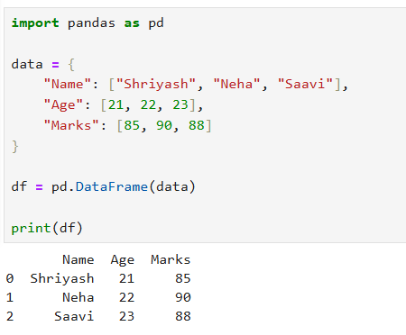
Simple Example Code

5. Basic Data Structures in Pandas
Pandas provides two primary data structures for handling data.
5.1 Series
A Series is a one-dimensional labeled array capable of holding data of any data type such as integers, floats, strings, or Python objects. The labels associated with the values are called the index.

Characteristics of Series:
• It is similar to a single column in a table.
• It stores data values along with index labels.
• It can contain different data types.

Series can be created from:
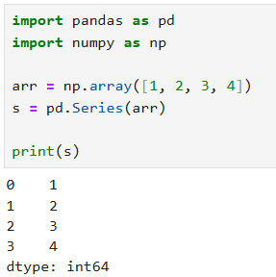
• NumPy arrays

• Python lists
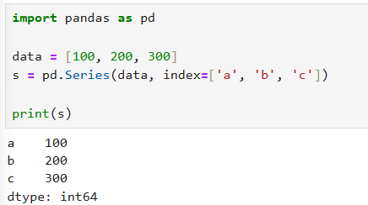
• Dictionaries
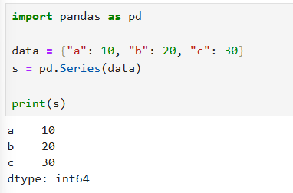
• Scalar values
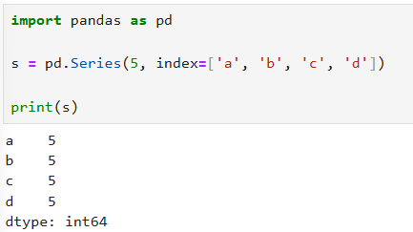
The index allows users to access elements easily using labels.

5.2 DataFrame
A DataFrame is a two-dimensional data structure used to store data in rows and columns.
It is similar to:
• A spreadsheet
• A SQL table
• A structured dataset

Characteristics of DataFrame:
• Consists of rows and columns
• Each column can contain different data types
• Supports data manipulation and analysis operations

A DataFrame can be created from:
• Dictionaries
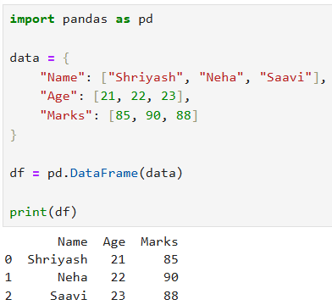

• Lists
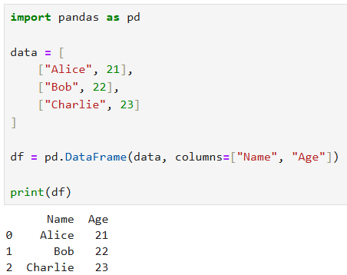
• NumPy arrays
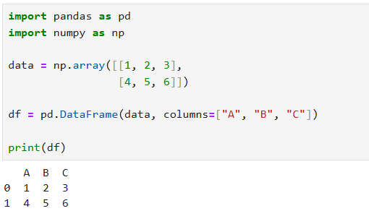

• CSV or Excel files
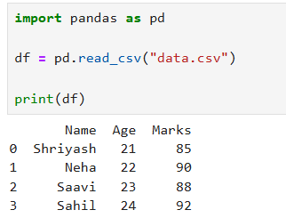
• Databases
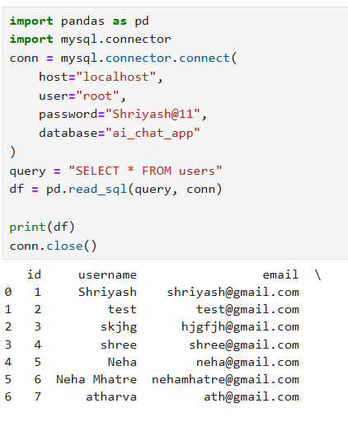
DataFrames are the most commonly used structure in data analysis and machine learning.

6. Exploring Data in Pandas
Pandas provides several functions to understand and explore datasets.

Columns
The columns attribute displays the names of all columns in the dataset.
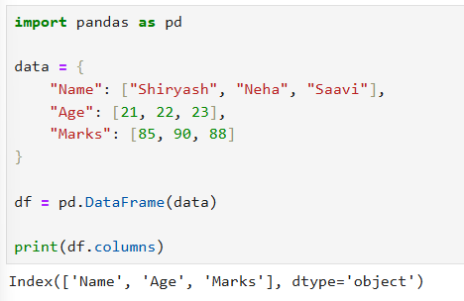
Head Function
The head() function displays the first few rows of the dataset.
This is useful for quickly understanding the structure of the dataset.
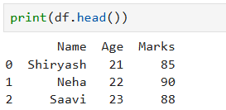
Tail Function
The tail() function displays the last few rows of the dataset.
This helps verify whether the dataset has been loaded correctly.
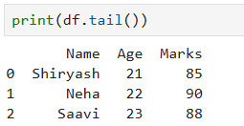
Sample Function
The sample() function returns random rows from the dataset.
It is useful when working with large datasets and you want to examine a random portion of data.
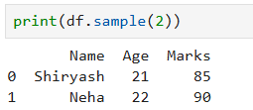

7. Accessing Data in Pandas
Pandas provides multiple methods to access and manipulate data.

Column Access
Columns can be accessed using their column names.
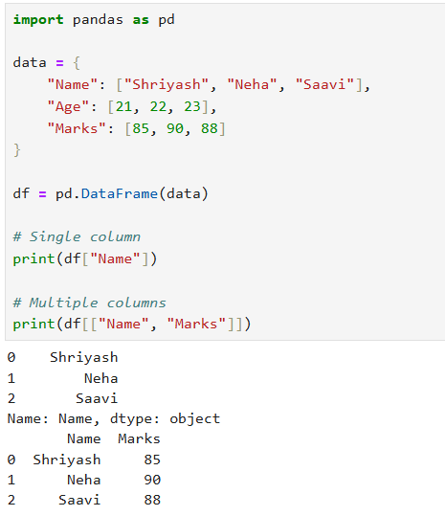
Selecting a single column returns a Series, while selecting multiple columns returns a DataFrame.

loc (Label-Based Indexing)
The loc method is used to access rows and columns based on labels.
It allows selection using:
• Row labels
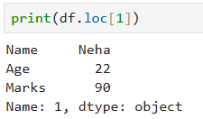
• Column labels
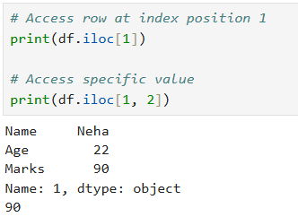

• Boolean conditions
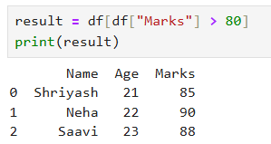
iloc (Integer-Based Indexing)
The iloc method is used to access rows and columns based on integer position.
It is similar to indexing in arrays where positions start from 0.
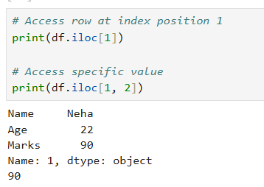
at Method

The at method is used to access a single value in the DataFrame using row label and column label.
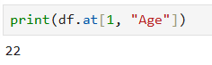
iat Method
The iat method is used to access a single value using integer row and column positions.
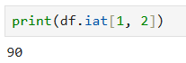

8. Determination of Data Types
In Pandas, each column in a dataset has a specific data type.

Common data types include:
• int64 – integer values
• float64 – decimal numbers
• object – text or mixed data
• bool – boolean values
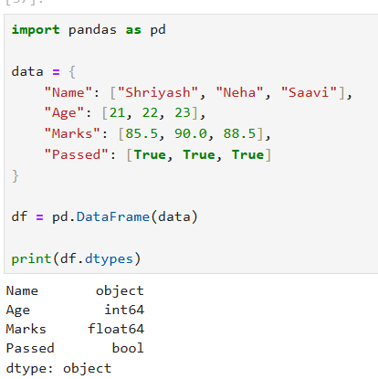
The dtypes attribute is used to display the data type of each column.
Understanding data types is important for data preprocessing and analysis.

9. Dataset Information
The info() function provides detailed information about the dataset.

It displays:
• Total number of rows
• Column names
• Non-null values in each column
• Data types of columns
• Memory usage
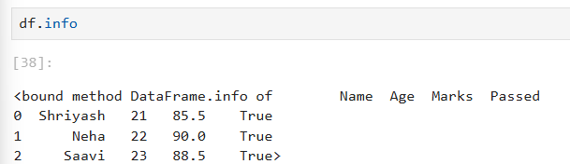
This helps identify missing values and incorrect data types.

10. Descriptive Statistics
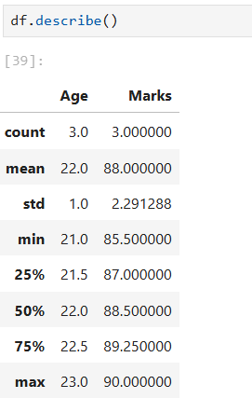
Pandas provides the describe() function to generate statistical summaries of numerical data.
It includes:
• Count
• Mean
• Standard deviation
• Minimum value
• 25th percentile
• Median (50th percentile)
• 75th percentile
• Maximum value

These statistics help understand the distribution of the dataset.

11. Unique Values and Frequency
Pandas provides functions to analyze categorical data.

Unique Values
The unique() function returns distinct values present in a column.
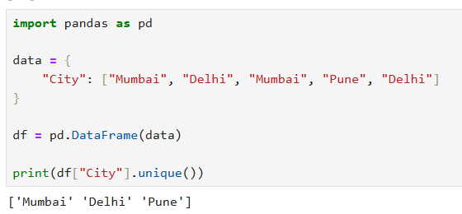

Value Counts
The value_counts() function counts the frequency of each category in a column.
This helps analyze class distribution in datasets.
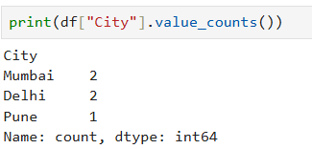

Feature | Series | DataFrame
Dimension | One-dimensional | Two-dimensional
Structure | Single column | Multiple columns
Data Types | Can hold any type of data | Each column may have different data types
Example | Student marks column | Complete student dataset

13. Result
The experiment successfully demonstrated data manipulation and analysis using Pandas, including
Series creation, DataFrame operations, data exploration, indexing, and missing value detection.

14. Conclusion
Pandas is a powerful library for data analysis and preprocessing. It enables efficient manipulation of
large datasets and plays a crucial role in machine learning and data science workflows.

Viva Questions

1. What is Pandas?
Pandas is an open-source Python library used for data manipulation, analysis, and cleaning of structured data.

2. What is a Series in Pandas?
A Series is a one-dimensional labeled array capable of holding data of any type such as integers, floats, or strings.

3. What is a DataFrame?
A DataFrame is a two-dimensional data structure with rows and columns, similar to a table or spreadsheet.

4. What is the difference between Series and DataFrame?
A Series is one-dimensional (single column), while a DataFrame is two-dimensional (multiple columns and rows).

5. What is NaN in Pandas?
NaN (Not a Number) represents missing or undefined values in a dataset.

6. What does the head() function do?
The head() function displays the first few rows of a dataset, usually the first 5 rows.

7. What is the use of tail()?
The tail() function displays the last few rows of the dataset.

8. What is the difference between loc and iloc?
- loc → Access data using labels (row/column names)
- iloc → Access data using integer positions (index numbers)

9. What is the use of describe()?
The describe() function provides statistical summary of numerical data such as mean,
count, min, max, and percentiles.

10. What is value_counts()?
The value_counts() function counts the frequency of unique values in a column.

11. What is the purpose of info()?
The info() function displays summary information about the dataset, including column names, data types, non-null values, and memory usage.

